Prepared by: National Cancer Programme

Targeted Lung Health Checks Programme
Standard Letters for Participants
- Overview

Participants receive different letters at different times during their journey through the NHS England Targeted Lung Health Checks Programme (TLHC). Standard letters have been developed in partnership with members of the Lung Health Sub-Group of the Cancer Clinical Expert Group, colleagues at Royal Marsden Partners and University College London, the Roy Castle Foundation patient reader panel, the NHS England Patient and Public Voice Forum, alongside input from colleagues at the Hillingdon and Fulham, and Luton and Thurrock TLHC projects.

The letters are also accompanied by a Participant Information Booklet to inform them about the process involved and basic background information on lung health and the programme itself. This leaflet is sent with any correspondence to the Participant up until they attend their Lung Health Check.

They reflect the Participant Journey from initial invitation stage through to CT scanning and communicating results, ensuring their GP is kept informed of the process and any outcomes. This is reflected in the standard protocol which can be found here.

- Standard Letters and Recipients

Pathway | Letter | Details | From | To | CC
 | P1 | First invite (with Participant Information Booklet) | GP | P
 | P2 | Reminder first invite (with Participant Information Booklet) | GP | P
 | P3 | Confirm lung health check appointment (with Participant Information Booklet) | Project | P | GP
 | P4 | Deferred first scan reminder  (NA if CT scan same day as LHC) | Project | P | GP
C | P5 | Repeat 24-month scan | Project | P | GP
B2 | P6 | Repeat 12-month scan | Project | P | GP
B1 | P7a | Repeat 3-month scan | Project | P | GP
B1 | P7b | Following 3-month scan repeat 12 months scan | Project | P | GP
C | P8 | Reminder repeat 24 months scan | Project | P
B1 | P9 | Reminder repeat 3 months scan | Project | P
B1/B2 | P10 | Reminder repeat 12 months scan | Project | P
A | P11 | Findings | Project | P | GP
Discharge | P12 | Discharge from B1, B2 following intermediary LDCT at 3 or 12-month from baseline | Project | P | GP
Discharge | P13 | Discharge from C following LDCT 24-month from baseline with no intermediary scan | Project | P | GP
*NOTE
Communications regarding incidental findings should be managed locally by projects, as noted in section 7.4.2.3 of the TLHC Programme Standard Protocol.

Letter P11 in this pack can be adapted to communicate incidental findings that require further investigation.

Each local system will have its own process in place for dealing with such outcomes and should adapt the communication to detail next steps accordingly.

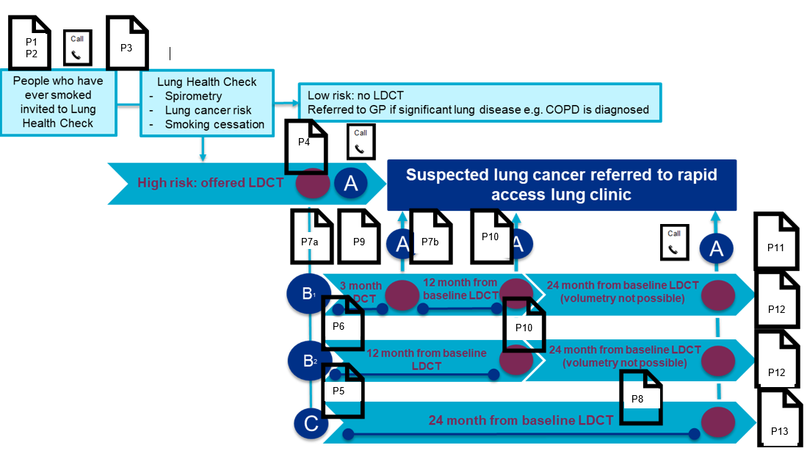

P1
PARTICIPANT NAME
PARTICIPANT ADDRESS
DATE
尊敬的PARTICIPANT
关于：免费肺部健康检查邀请
我们与英国 NHS 合作提供免费的肺部健康检查，希望邀请您安排预约。
随附一本小册子，更详细地说明什么是肺部健康检查。
如需安排您的预约或了解更多信息，请致电：
TELEPHONE NUMBER
谨致问候！
NAME OF GP
GP PRACTICE
附
我们希望收集参与者接受有针对性的肺部健康检查的体验。您可能会收到 Ipsos MORI 代表英国 NHS 发出的反馈问卷和改进。如果您不希望提供任何反馈，请忽略此反馈调查问卷。

P2
PARTICIPANT NAME
PARTICIPANT ADDRESS
DATE
尊敬的PARTICIPANT
关于：提醒 — 免费肺部健康检查邀请
继我上一次发出的日期为 INSERT DATE LETTER P1 SENT 的信件之后，我想提醒您安排您的免费肺部健康检查预约。
随附一本小册子，更详细地说明什么是肺部健康检查。
如需安排您的预约或了解更多信息，请致电：
TELEPHONE NUMBER
谨致问候！
NAME OF GP
GP PRACTICE
附
我们希望收集参与者接受有针对性的肺部健康检查的体验。您可能会收到 Ipsos MORI 代表英国 NHS 发出的反馈问卷和改进。如果您不希望提供任何反馈，请忽略此反馈调查问卷。

P3
PARTICIPANT NAME
PARTICIPANT ADDRESS
DATE
尊敬的PARTICIPANT
关于：您的肺部健康检查预约确认
感谢您预约免费肺部健康检查。
您的预约的详细信息如下：
NAME OF SPECIALIST NURSE
DATE
TIME
LOCATION
如果您无法赴约，希望重新安排，或有任何疑问，请致电：
TELEPHONE NUMBER
随附一本小册子，更详细地说明什么是肺部健康检查。
谨致问候！
LUNG HEALTH CHECK PROJECT TEAM
附
我们希望收集参与者接受有针对性的肺部健康检查的体验。您可能会收到 Ipsos MORI 代表英国 NHS 发出的反馈问卷和改进。如果您不希望提供任何反馈，请忽略此反馈调查问卷。

P4
PARTICIPANT NAME
PARTICIPANT ADDRESS
DATE
尊敬的PARTICIPANT
关于：CT扫描提醒（肺部健康检查预约之后）
关于您预约于 [insert date attended lung health check]进行的肺部健康检查，我们想提醒您接受CT扫描的日期。
您的预约的详细信息如下：
NAME OF HEALTH PROFESSIONAL:
DATE:
TIME:
LOCATION:
如果您无法赴约，希望重新安排，或有任何其它疑问，请致电：
TELEPHONE NUMBER
请查收随附的肺部健康检查详细说明小册子。
谨致问候！
LUNG HEALTH CHECK PROJECT TEAM
附
我们希望收集参与者接受有针对性的肺部健康检查的体验。您可能会收到 Ipsos MORI 代表英国 NHS 发出的反馈问卷和改进。如果您不希望提供任何反馈，请忽略此反馈调查问卷。

P5
PARTICIPANT NAME
PARTICIPANT ADDRESS
DATE
尊敬的 PARTICIPANT
关于：肺部健康检查 — CT 扫描结果
感谢您参加 DATE 的肺部健康检查预约和 CT 扫描。
我们很高兴 通知 您， 您的 CT扫描 没有显示出 肺癌 迹象， 无需进一步检查。
这并不能保证您将来不会患上肺部疾病，所以一定要留心。
如果出现任何令您担心的症状， 请联系您的 GP 。 此类症状包括 胸痛、呼吸困难、持续三周以上的新发咳嗽或现有咳嗽出现的变化。
我们将在24个月后与您联系，邀请您 预约复查您的肺部健康。
该预约的时间将为 INSERT MONTH AND YEAR。 时间临近时，您将收到一封含有预约详细信息的信 件。
此信件的副本也将发送给您的 GP。
如果您有任何疑问，请致电：
TELEPHONE
谨致问候！
LUNG HEALTH CHECK PROJECT TEAM

P6
PARTICIPANT NAME
PARTICIPANT ADDRESS
DATE
尊敬的PARTICIPANT
关于：肺部健康检查 — CT 扫描结果
感谢您赴约参加肺部健康检查。
您于 INSERT DATE OF SCAN进行的肺部 CT 扫描显示有一个名为结节的小点。
这在扫描结果中很常见，通常无需担心。在大多数情况下，这是肺部的疤痕或炎症区域。
请放心，这不需要立即跟进或进一步检查。
我们将邀请您12个月之后回来预约检查您的肺部健康。您的预约的详细信息如下：
NAME OF SPECIALIST NURSE
DATE
TIME
LOCATION
如果您无法赴约，希望重新安排，或有任何其它疑问，请致电：
TELEPHONE NUMBER
如果在此期间您出现任何让您担心的症状，请 联系您的 GP。此类症状包括 胸痛、呼吸困难、持续三周以上的新发咳嗽或现有咳嗽出现的变化。
谨致问候！
LUNG HEALTH CHECK PROJECT TEAM

P7a
PARTICIPANT NAME
PARTICIPANT ADDRESS
DATE
尊敬的PARTICIPANT

关于：肺部健康检查 — CT 扫描结果
感谢您赴约参加肺部健康检查。
您于 INSERT DATE OF SCAN进行的肺部 CT 扫描显示有一个名为结节的小点。
这在扫描结果中很常见，通常无需担心。在大多数情况下，这是肺部的疤痕或炎症区域。
请放心，这不需要立即跟进或进一步检查。
我们将邀请您3个月之后回来预约检查您的肺部健康。您的预约的详细信息如下：
NAME OF SPECIALIST NURSE
DATE
TIME
LOCATION
如果您无法赴约，希望重新安排，或有任何其它疑问，请致电：
TELEPHONE NUMBER
如果在此期间您出现任何让您担心的症状，请 联系您的 GP。此类症状包括 胸痛、呼吸困难、持续三周以上的新发咳嗽或现有咳嗽出现的变化。
谨致问候！
LUNG HEALTH CHECK PROJECT TEAM

P7b
PARTICIPANT NAME
PARTICIPANT ADDRESS
DATE
尊敬的PARTICIPANT
关于：肺部健康检查 — CT 扫描结果
感谢您参加肺部健康检查3个月扫描。
您可能还记得，您的第一次CT扫描显示有一个小的结节。正如当时所说明的，这在检查中比较常见，多数情况下是肺部疤痕或炎症的区域。这通常无需担心。
我们希望12个月后对您的肺部再做一次扫描，看看是否有任何变化。
该预约的时间将为INSERT MONTH/YEAR。时间临近时，您将收到一封含有预约详细信息的信件。
如果您无法赴约，希望重新安排，或有任何其它疑问，请致电：
TELEPHONE NUMBER
如果在此期间您出现任何让您担心的症状，请 联系您的 GP。此类症状包括 胸痛、呼吸困难、持续三周以上的新发咳嗽或现有咳嗽出现的变化。
谨致问候！
LUNG HEALTH CHECK PROJECT TEAM

P8
PARTICIPANT NAME
PARTICIPANT ADDRESS
DATE
尊敬的PARTICIPANT
关于：后续 CT 扫描
您在 INSERT DATE进行过一次 CT 扫描。我们想提醒您参加24个月间隔的后续预约。
您的预约的详细信息如下：
NAME OF HEALTH PROFESSIONAL:
DATE:
TIME:
LOCATION:
如果您无法赴约，希望重新安排，或有任何其它疑问，请致电：
TELEPHONE NUMBER
谨致问候！
LUNG HEALTH CHECK PROJECT TEAM

P9
PARTICIPANT NAME
PARTICIPANT ADDRESS
DATE
尊敬的PARTICIPANT
关于：后续 CT 扫描
您在 INSERT DATE进行过一次 CT 扫描。我们想提醒您参加3个月间隔的后续预约。
您的预约的详细信息如下：
NAME OF HEALTH PROFESSIONAL:
DATE:
TIME:
LOCATION:
如果您现在无法赴约，请拨打以下号码通知我们，或安排新的预约：
TELEPHONE NUMBER
谨致问候！
LUNG HEALTH CHECK PROJECT TEAM

P10
PARTICIPANT NAME
PARTICIPANT ADDRESS
DATE
尊敬的PARTICIPANT
关于：肺部健康检查 — 后续 CT 扫描
您在 INSERT DATE进行过一次 CT 扫描。我们想提醒您参加12个月间隔的后续预约。
您的预约的详细信息如下：
NAME OF HEALTH PROFESSIONAL:
DATE:
TIME:
LOCATION:
如果您现在无法赴约，请拨打以下号码通知我们，或安排新的预约：
TELEPHONE NUMBER
谨致问候！
LUNG HEALTH CHECK PROJECT TEAM

P11
PARTICIPANT NAME
PARTICIPANT ADDRESS
DATE
尊敬的PARTICIPANT
关于：肺部健康检查结果
感谢您赴约参加肺部健康检查和CT扫描。
我们给您打过电话。这是为了确认您的扫描显示出一些需要进一步检查的结果。
INSERT FINDINGS
我们已经为您转诊至INSERT REFERRAL LOCATION，他们将直接联系您。我们已经将此次转诊告知您的 GP 。
如果您有任何疑问，请致电：
TELEPHONE NUMBER
谨致问候！
LUNG HEALTH CHECK PROJECT TEAM

P12
PARTICIPANT NAME
PARTICIPANT ADDRESS
DATE
尊敬的 PARTICIPANT
关于：肺部健康检查 — 后续扫描结果
感谢您赴约参加DATE 的肺部健康检查预约和 CT 扫描。
我们安排这次后续扫描是因为之前的扫描显示您的肺部有一个或多个结节。
我们很高兴通知您，您的 CT 扫描没有显示出肺癌迹象，无需进一步检查。
这并不能保证您将来不会患上肺部疾病，所以一定要留心。
如果出现任何令您担心的症状，请联系您的 GP 。此类症状包括胸痛、呼吸困难、持续三周以上的新发咳嗽或现有咳嗽出现的变化。
肺部健康检查服务将不会再次与您联系。如果您有任何疑问，请致电：
TELEPHONE NUMBER
此信件的副本也将发送给您的 GP。
谨致问候！
LUNG HEALTH CHECK PROJECT TEAM

P13
PARTICIPANT NAME
PARTICIPANT ADDRESS
DATE
尊敬的 PARTICIPANT
关于：肺部健康检查 — 24个月后续扫描结果
感谢您赴约参加DATE 的肺部健康检查预约和 CT 扫描。
您受邀接受扫描是因为您的肺部健康检查预约显示您符合条件。每个接受初次肺部健康检查扫描的人都有机会接受一次后续扫描。
我们很高兴通知您，您的 CT 扫描没有显示出肺癌迹象，无需进一步检查。
这并不能保证您将来不会患上肺部疾病，所以一定要留心。
如果出现任何令您担心的症状，请联系您的 GP。此类症状包括胸痛、呼吸困难、持续三周以上的新发咳嗽或现有咳嗽出现的变化。
肺部健康检查服务将不会再次与您联系。如果您有任何疑问，请致电：
TELEPHONE NUMBER
此信件的副本也将发送给您的 GP。
谨致问候！
LUNG HEALTH CHECK PROJECT TEAM

